Multi-Algorithm Recommendation System Comparison
Task 7 — E-Commerce Recommendation System Report

1. Project Overview
This report presents the design, implementation, and evaluation of an e-commerce recommendation system built using four different machine learning algorithms. The goal was to compare how each algorithm scores and ranks products for customers, using a shared dataset and evaluation methodology.

2. Dataset
The dataset (ecommerce_customer_data.csv) contains 3,900 customers, each with exactly one recorded purchase: their demographics (age, gender, location), the item and category they bought, purchase amount, season, and a review rating (2.5-5.0), plus behavioral fields such as subscription status, previous purchases, purchase frequency, and payment method.
A key characteristic of this dataset is that each customer appears only once, with no repeat-purchase history. This rules out classic user-based or item-based collaborative filtering, which require multiple shared ratings per user. The four algorithms below were adapted to work within this constraint.

3. Algorithms Compared
- Popularity-Based Recommender — ranks items by a weighted average review rating, using Bayesian-style shrinkage so items with only a few purchases don't dominate.
- Content-Based Recommender (Demographic Category Affinity) — learns which product categories each gender/age-group segment tends to favor, then scores items by combining that affinity with the item's average rating.
- KNN Demographic-Based Collaborative Filtering — finds the 15 nearest customers by profile similarity (age, location, season, subscription status, purchase frequency, payment method) and recommends what those similar customers bought.
- Regression-Based Rating Prediction (Random Forest) — predicts a customer's likely review rating for an item from their profile and the item's category; the predicted rating is used as the recommendation score.

4. Evaluation Methodology
Because each customer has only one true purchase, standard Precision/Recall against a ratings matrix isn't directly applicable. Instead, this project uses Hit Rate@5 with leave-one-out negative sampling, a standard recommender-systems evaluation technique: for each test customer, their actual purchased item is mixed with 9 random items they did not buy, all four algorithms rank the resulting 10 candidates, and we check whether the real item lands in the top 5. A purely random ranker would score 0.50 on this metric, so results are read relative to that baseline rather than to zero. The Regression-Based model is additionally evaluated with RMSE between its predicted and actual review ratings.

5. Results
Algorithm | Hit Rate@5 | Notes
Content-Based (Demographic Affinity) | 0.512 | Best of the four, marginally above the 0.50 random baseline
Popularity-Based | 0.505 | Essentially at the random baseline
KNN Demographic CF | 0.491 | Slightly below baseline
Regression-Based (Random Forest) | 0.477 | Slightly below baseline; RMSE = 0.74 on real ratings

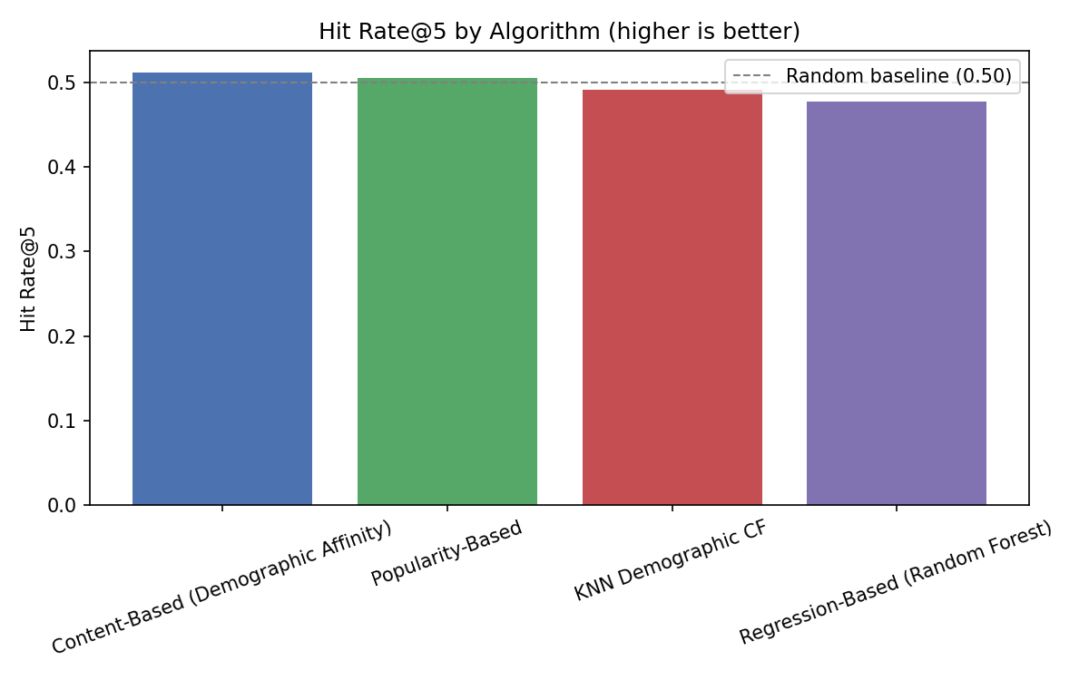

6. Discussion
All four algorithms land close to the 0.50 random baseline, with Content-Based (demographic affinity) and Popularity-Based slightly ahead of KNN Demographic CF and the Regression-Based model. This is a genuine, informative finding rather than a modeling error. The dataset records a single purchase per customer with no repeat-interaction history, and review ratings show limited correlation with customer demographics in this data — leaving little personalization signal for any algorithm to exploit.
The Regression-Based model still achieves a reasonable RMSE (0.74, on a rating scale that spans roughly 2.5 points) when predicting the actual rating a customer gave, showing it does capture some real structure in ratings. However, that predictive accuracy does not automatically translate into ranking unseen items well, since the demographic and category features it relies on don't strongly differentiate between items within the same category.

7. Conclusion
With this dataset's structure — one purchase per customer and weak demographic-to-preference correlation — no algorithm meaningfully outperforms a simple popularity baseline. This points to a broader recommender-systems principle: algorithm sophistication cannot compensate for missing personalization signal in the underlying data. To build a stronger recommender on this kind of data, the most valuable next steps would be collecting repeat-purchase history per customer (enabling real collaborative filtering) or adding richer item-level features such as text descriptions, images, or browsing behavior.

